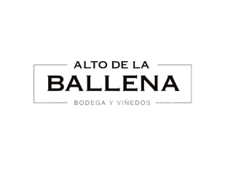

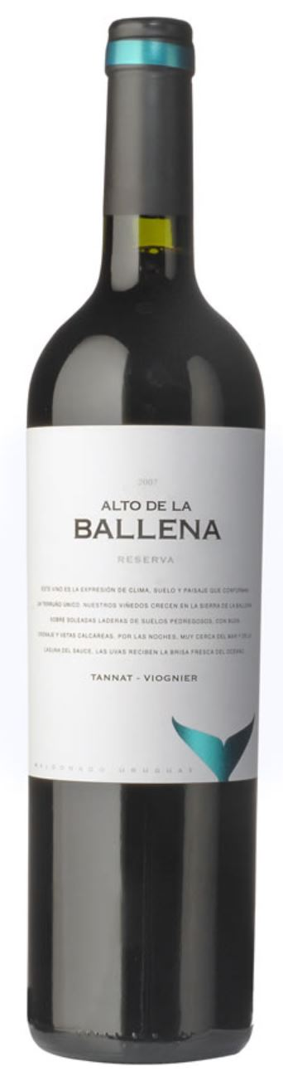
TANNAT-VIOGNIER

The careful management of the vineyard and a very low yield per plant achieved great concentration. Each variety was harvested manually and in small boxes at its optimum moment of maturity.

Technical Description
Vintage: Manual
Method: Stalk Removing
Alcoholic Fermentation: 12 days temperatures no higher than 30º C.
Malolactic Fermentation: New French Oak Barrels
Ageing: 9 months in French Oak Barrels

Tasting Note
Color: Deep red violet.
Nose: Intense and complex roma, in which a mixture of red fruits, spices and wild flowers melts on an elegant vanilla background.
Palate: The palate has a soft and pleasant entry. Good structure, persistent finish.
Recommendations
Ideal drinking temperature: 17º C.
Pairing: Cold meats, grilled fish and meat, as well as small game.

